**Four compelling insights of Seattle homestay market**

1. **Introduction**

Homestay is becoming a popular choice for many travelers because of its reasonable price, opportunities to make new friends and become immersed in a new culture. Are you planning a homestay in Seattle? Have you tried to research the homestay market in Seattle? You probably see a lot of information and you probably know Airbnb as well. This blog will provide you fascinating insights from the Seattle homestay market that is based on Airbnb data in 2016.



1. **Compelling insights**

**Insight 1: When is the right time for a trip**

Deciding a trip will be based on a lot of factors such as your budget, available time, things you want to experience…You should agree with me that budget is one of the most important factors. Based on Airbnb data in Seattle, I found an interesting insight about rental price. Let’s see the chart below:

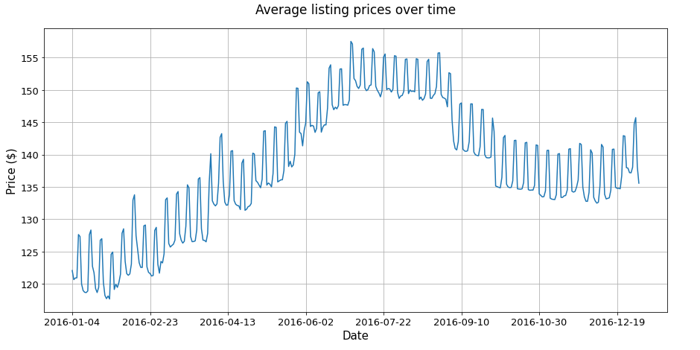

We can see that homestay prices stayed low in January and February, then it gradually went up to reach a peak in June, July and August before going down in the rest of the year but it was still higher than in the first few months of the year. So, based on this chart you can plan your budget accordingly. If you have a limited budget then June, July and August may not be the suitable time for you.

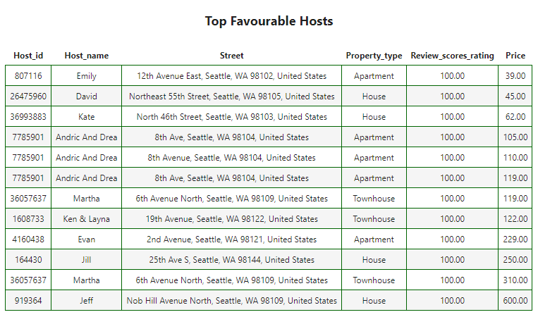**Insight 2: What are the top listing hosts in Seattle**

Reviews from visitors who experienced homestays in Seattle could give you valuable information. Based on Airbnb data in Seattle 2016, I come up a list of top hosts in the area. These hosts have maximum scores about rating, location, value, cleanliness and communication.

**Insight 3: Which property types suit you?**

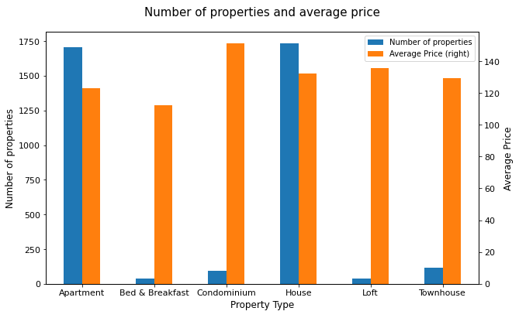There are many types of property you can pick for a homestay. I list here the most common types in the market.Apartment and House were dominant types in Seattle, you probably go with one of the two types if you have a homestay there. About price, Condominium had the highest average fee while Bed & Breakfast charged lowest. For other types, prices did not differ much.

**Insight 4: How do hosts’ response time and rate relate to customer ratings?**

Research data provided by Airbnb, I find that the faster hosts responded to customer’s queries, the higher rating they received from users. Similarly, hosts with high response rates also get higher ratings from clients. The heat map below reveals that information:

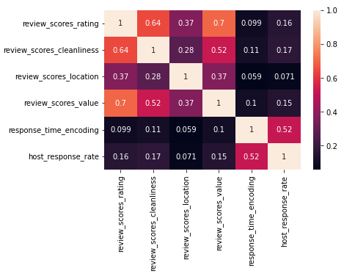

1. **Conclusion**

Above are four compelling insights from the Seattle homestay market. So whether you are going to have a homestay there or you are becoming a host in Seattle, keep in mind that:

* Homestay prices were low at the beginning of year and peak in the middle of the year then go down moderately in end-year months.
* A top host list can give you a quick search for high rated hosts
* House and apartment are two dominant property types in Seattle. Condominiums had the highest charge while “Bed & Breakfast” had the lowest price.
* Hosts with high response rates and fast responses to customers would receive high ratings. This is useful for hosts to know how to improve rates as well as for travelers to find good homestays.